Christ Church scandal: Lavinia Woodward, college dean Martyn Percy and the censors

Christ Church is one of Oxford’s richest colleges. Three years ago, it was rocked by the student Lavinia Woodward’s assault case. But it’s what has happened since that has set don against dean and led to the latter’s suspension. The most toxic conflict in academia is far from over. Andrew Billen reports
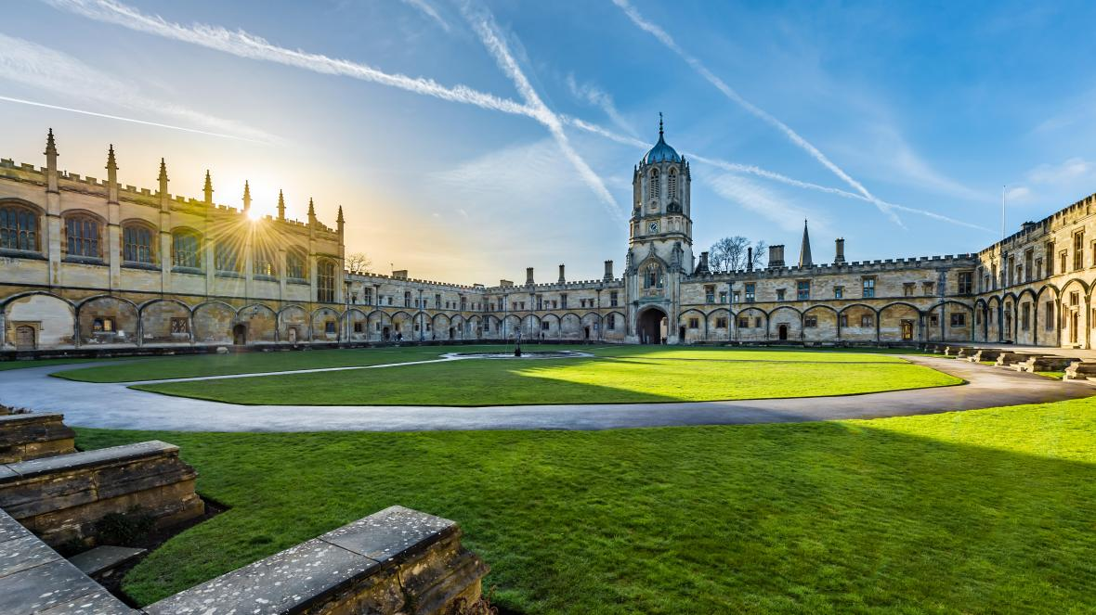
Christ Church, Oxford
ANTHONY P MORRIS/ALAMY
Andrew Billen
Saturday February 29 2020, 12.01am, The Times

It began with an assault. In December 2016 at Christ Church, one of the oldest and richest Oxford colleges, a brilliant medical student, Lavinia Woodward, rowed with a boyfriend. When he, alarmed, threatened to contact her mother on Skype, she punched him in the face, hurled a laptop and jam jar at him and stabbed him in the leg with a bread knife. She later pleaded guilty to unlawful wounding, but the case gained national notoriety because the judge suspended her ten-month jail sentence on the grounds that she was “an extraordinarily able young lady” and that sending her to prison would damage her hopes of becoming a surgeon. Woodward volunteered to suspend her studies for the ten months but, in fact, never returned to Christ Church.
Yet this is not a story about Lavinia Woodward. It is the story of how a professor at Christ Church blew the whistle on an archaic and inadequate safeguarding regime that had failed her, and claims of how a cabal of academics conspired first to thwart and then delay his proposed reforms before working to remove him from office. The whistleblower was not a junior employee, a naive young don, but the head of the college, the dean of Christ Church himself, the Very Rev Professor Martyn Percy.
In the three years since the stabbing, Percy has been accused by his own college of “immoral, scandalous and disgraceful conduct”, suspended from his duties, and then reinstated after a retired high court judge who chaired a secret tribunal on the accusations against him found that he had committed next to no disciplinary offence. What follows here is the untold story of the ordeal of Martyn Percy, a tale of vilification (one of his tormentors playfully asked if anyone knew of a good poisoner; another imagined his “withered body being discovered in a local lock”), plotting and an isolated man’s resilience. It is also a tale with no resolution. Despite his vindication by the judge, a motion of no confidence was passed against him in December. Percy is now preparing to take the college to an employment tribunal. He is, in short, refusing to go, but his detractors have not given up on their fight either. Meanwhile the reputation and finances of a college founded by Cardinal Wolsey in 1525, then refounded by Henry VIII in 1546, declines.
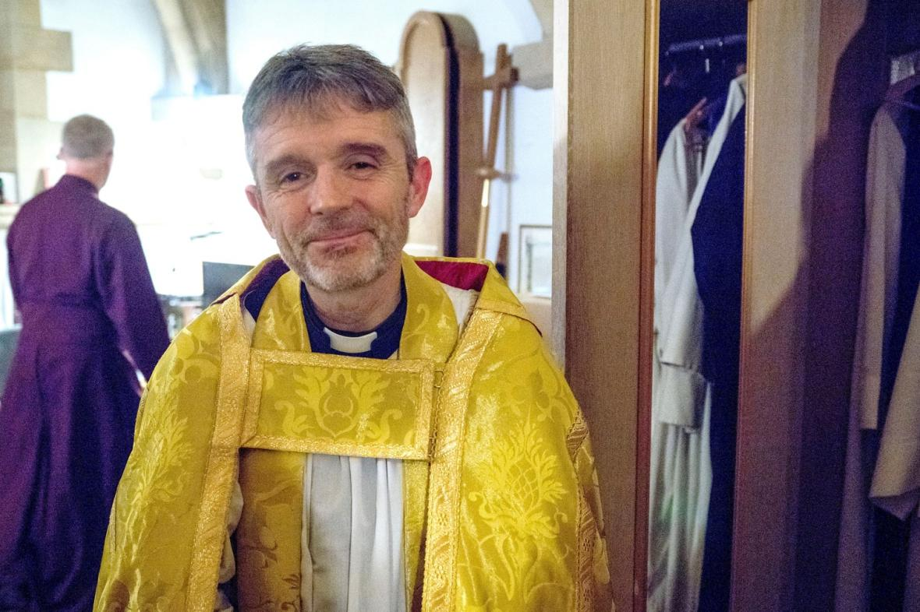
The dean, the Very Rev Professor Martyn Percy
SHUTTERSTOCK
The college has always insisted this is a dispute over the dean’s pay that turned sour and led to a breakdown of communications, then to it losing confidence in him. Internal emails and other documentation including a judgment from the tribunal last summer have recently been seen by The Times. They suggest a narrative much darker and more worrying than an employment dispute. And it does, indeed, begin with Lavinia Woodward.

On the day of the assault, Percy had been at the funeral of his wife’s brother whom the Percys had cared for in the last six months of his life. When he returned, the college was in turmoil and he took command. Shocking though the incident was to Percy, what soon disturbed him more was that the college appeared to have no safeguarding policies or procedures in place to prevent anything like it happening again. Indeed, as I understand, it was left to the dean himself to attend to Woodward at the height of her distress.
The college’s ad hoc response to the Woodward emergency turned out, in his view, to be symptomatic of a lack of professionalism in its welfare provision, a responsibility which he thought rested lightly on the shoulders of the college “censors”. At Christ Church, “censor” is the term for academics who, in four-year terms and in return for extra pay, take on responsibility for the academic life of the college, its discipline and many aspects of its social life. There is a senior censor, a junior censor (who will eventually succeed his or her senior colleague) and an “academic registrar”, who supports the senior censor.
Nine months after the Woodward affair, in September 2017, Geraldine Johnson, a history of art professor, was appointed junior censor. She was shocked at her new role’s lack of clarity. She complained about the handling of a “suicide attempt and a sexual assault case” that had recently come to her notice. A month after her appointment, Johnson wrote, “This should be a straightforward question, but I can’t believe I’m asking it: who is officially the overall Welfare lead in the College? Am I? The Dean? The Chaplain?? I need to know for all sorts of reasons, but most urgently because the Junior Censor (JC) is currently listed as the ‘Child Safeguarding Lead’ on the College website about such things. I simply can’t be that because that is a technical term that implies particular training, as we discussed, which I don’t have.”
‘I have resisted these charges,’ said Percy at a lecture, ‘at considerable cost’
In early 2017, Percy called a meeting of former censors, senior figures in the college, hoping to discuss the failures of oversight and the college’s legal noncompliance on safeguarding. Percy’s first call was for proper job descriptions to be drawn up for the censors in office so they at least could understand what their duties were (child safeguarding was among these duties because not all students are 18 or over when they arrive, and most entrance candidates who spend several days at the college for interviews are not either).
Rather than, as you might expect, quickly setting about this task, the documents suggest the former censors were seemingly infuriated by Percy’s interference and began to mobilise against him, first to thwart or at least delay his reforms and, soon enough, to remove him. The real reasons can only be guessed at.
Christ Church’s former censors are just that, former holders of the post. They have a handful of official duties – including advising on the removal of a dean from office – but have no power under the college statutes to manage its day-to-day business. In reality, they hold much greater informal sway and exercise enormous influence on the governing body, a 60-plus group made up of the entire academic staff, many of whom we may presume to be more concerned with their own research and teaching than governance. During the dispute with the dean the former censors were led by David Hine, an emeritus professor of politics who was “senior ex-censor” by virtue of having held the senior censor’s post longest ago.
It was Hine who convened meetings of other former censors – Edwin Simpson, Lindsay Judson, Ian Watson and others – to tackle Percy’s attempts at reform. This group was later extended to include Canon Sarah Foot, James Lawrie, the treasurer, and Karl Sternberg, a fellow of the college who advises Christ Church on investments. The existence of this committee of former censors is not openly acknowledged and its clandestine nature is confirmed by other emails. In 2016, for example, Hine, presumably correcting a typo in a previous message, emailed all the former censors: “Dear all, I know we meet in secret, but I didn’t intend to invite you at 1am.” A year later, he advised the group to communicate by WhatsApp on the grounds that it was safer than email. “FYI,” he wrote, “MPs now use it as a safe way of conspiring against the whips.”
Soon the former censors, the documents suggest, were doing their utmost to procrastinate over the new job descriptions. Hine’s concerns seem to have been that detailed job descriptions that included increased accountability and safeguarding duties would make future censors’ lives a misery. This was not Percy’s view. At a meeting in October 2017 with three of the group, Percy, following up earlier discussions, again stressed that the safeguarding failures were serious. It was that meeting, Hine later wrote, that helped persuade him that Percy “couldn’t stay because he would make everyone so miserable”.
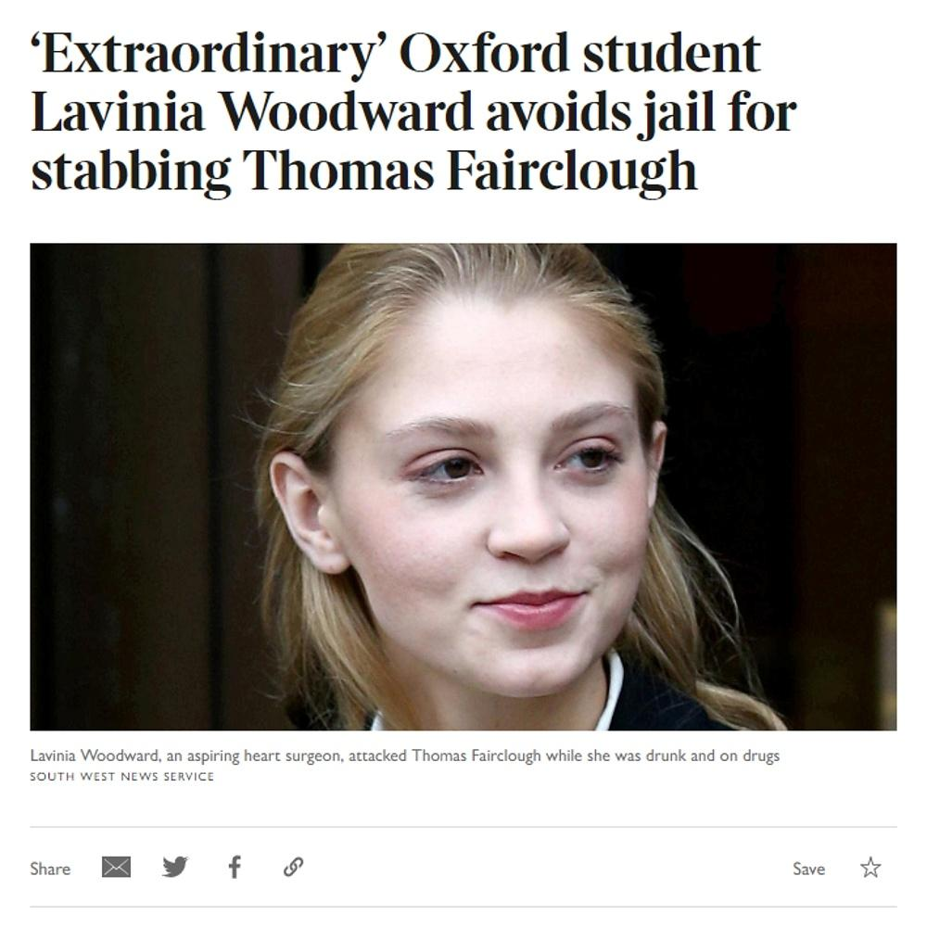
Times coverage of the Lavinia Woodward case
In November 2017, Johnson wrote to Hine to report that another alleged sexual assault and a suicide attempt had come to light “in the past three years”. Hine had also been told by then that the college had several minors in its care. One of them had been found “doused with drink”. It was becoming a real concern that the college may not have complied with the Safeguarding Vulnerable Groups Act 2006.
Only by December 2017, virtually a whole year after the Woodward incident, had Hine finalised a draft of those job descriptions. He told his secretive committee, however, that he did not want the descriptions to be shown to the governing body for fear of terrifying its members who might be censors themselves in due course. They would, he thought, fear they were being lined up for “time-consuming career-destroying four-year jobs”. “If we rub [the governing body’s] noses in how much there is to do – with great long documents – no-one will ever agree to be a Censor.”
The former censors seemed to be confident that they could find sufficient allies on the governing body to force Percy out. In the summer of 2018, Sternberg, a former chief investment officer of Deutsche Asset Management, wrote to the other group members of his plans to promote a no-confidence vote in the next governing body meeting. “It seems to me,” he emailed, “vital that we get sufficient numbers to win a no confidence vote, which means buying (say) two weeks in which all members [of the governing body] get to see all the relevant materials to make an informed judgement. It also becomes two weeks in which colleagues can have explained the breakdown and be lobbied [...] This situation is horrible and his [the dean’s] position is untenable.”
The former censors were fortunate in having been handed some ammunition by the dean himself. In the summer of 2017, well after the Woodward incident, Percy reported that as part of a salary review of staff at the college, he had discovered that he was underpaid by the standards of other college heads. This was accurate, although the information was not initially shared by Hine and indeed the college salaries board, whose secretary was another former censor, Judson. Hine felt that the pay rise “must be resisted at all costs”. Although Percy in 2017 was paid less than the college’s development director, it was clearly useful to Percy’s enemies for it to be known that he earned £90,000 a year, and had free housing in college and could take rent from a small flat above his residence if he let it out.
“
Emeritus Professor David Hine: ‘I’m always ready to think the worst of [the dean]. Does anyone know any good poisoners?’

And the cabal of senior censors by now certainly were his enemies, whether out of fears of time-consuming overregulation or because this was now a power struggle over who really ran the college. Their personal animosity towards the dean is shocking.
Hine in his emails shows a particular flair for invective. He writes of the dean on October 24, 2017, “His low-grade mind … can’t deal with [these questions] clinically and analytically, even if it can grasp the general idea … [The dean] is so stupid, so spiteful towards tutors and exC[ensors]s …” Hine calls Percy “a creep” on November 7 and writes the next day that he is “nasty and stupid … He’s got to go.” On November 23 he emails with more than a touch of the macabre, “I’m always ready to think the worst of him … We need a reset. Does anyone know any good poisoners?”
Sternberg, meanwhile, writes on November 15, 2017, to Hine that Percy is “a manipulative little turd” and “the little Hitler” and adds, “We are all doomed with this wretched man in place.” January 11, 2018: “He’s incorrigible, and thick and a narcissist … [T]he college has a serious problem unless he is forced out.” On January 27, he jokes in exasperation: “It must stop – please, please ex-Censors – get rid of him. Just think of the Inspector Morse episode we could make when his wrinkly withered little body is found at Osney Lock.” Much later in the year, Sternberg mentions the “ongoing Percy fiefdom” and “Mrs Dean’s verbal diarrhoea”. He writes on October 12 that Percy is “suffering what a medical practitioner said was a personality disorder”.

In a letter to Judson of the salaries board the following February, Percy set out his own “state of mind”. He complained about a lack of “care and support” and a “malfunctioning Censors office”, and, in relation to the Woodward incident, claimed his colleagues had “failed to take an appropriate share of responsibility for their failure of oversight or indeed to apologise” for the fact that only he had been available to deal with the incident. The dean received no reply.
Foot and Hine tried to bring the Bishop of Oxford into the dispute, in July 2018 contacting the Rt Rev Dr Steven Croft in their “personal capacity” to say Percy might need support and to ask whether he knew anyone close to the dean who might advise him “that a quiet negotiated and consensual exit may leave him with dignity and a chance to continue his Anglican career”.
Emeritus Professor David Hine, the leader of the group of former censors

Whatever the explanation for the plotting and vitriol, in November 2018, Percy was suspended pending a tribunal being held on its complaints as drawn up in September. The news made a few headlines, caused plenty of press speculation and puzzled Oxford academia. The phrase “immoral, scandalous and disgraceful conduct” inevitably was read by some to suggest that Percy had behaved improperly towards a student or a minor. In fact, it was simply the arcane form or words in the ancient college statutes that provided for the sacking of a dean. Over the Christmas break, the innuendo was nevertheless allowed to hang in the air. Percy largely confined himself to his college lodgings, not even going to dinner in hall.
Finally, in January the college wrote to all “valued member[s] of the Christ Church community” to explain itself. The college had been “mindful” of the dean’s “well-being at all times” since the suspension. Following a failure of mediation, the matter was going to a tribunal, as college statute allowed. It was, the community was told, worth stressing that the dispute did not concern “safeguarding”, code for any unholy dealings with students.
“Neither, contrary to press and social media speculation, does it concern issues relating to any supposed gender bias in the College, or a lack of commitment to access initiatives, or the pay of academic staff. We are not able to discuss the detailed basis of the complaint except to say that it relates to issues surrounding the Dean’s own pay and how it is set.”
This circular was signed by the censors.
A retired High Court judge, Sir Andrew Smith, adjudicated in London the following summer on whether Percy had behaved so badly during the pay dispute that he would have to go. But what took up a good proportion of the evidence heard before Sir Andrew was not about a wage claim. It was Percy’s arguments about the college’s governance and safeguarding responsibilities and his description of the efforts of the former censors to minimise them.
The tribunal, conducted in private, heard from ten witnesses. The dean was questioned for several days. At the end of it, Sir Andrew exonerated Percy on both the main charges and all 27 supporting charges. Percy was guilty of no “immoral, scandalous and disgraceful behaviour”. No details of the judgment were released.
Sir Andrew’s judgment is littered with his rulings that he does not accept the prosecution’s assertions. For instance, on their approach to the bishop, he concluded that, “There was no evidence before the Tribunal of a proper basis for concern about the Dean’s mental health.” Of a claim by Hine that at the height of the pay dispute he had threatened him personally with legal action, the judge wrote, “I have concluded [the dean] did not threaten to bring legal proceedings.”
Percy had in his early letters on the salary dispute used style that was “to put it mildly, punchy, and times unduly didactic ... some of the language was abrasive, caused understandable offence” and “detracted from the spirit of collegiality” to be expected. Sir Andrew went on to say, however, that when this was pointed out to him Percy apologised and that “the tone and language of the Dean’s correspondence changed markedly and, thereafter, it cannot, in my opinion, properly be criticised”.
Sir Andrew also noted that, “In and before 2017, the machinery of governance was not working well, and the Dean had carried some of the workload that might in other circumstances have been done by others, including the Censors.” The judge commented that the colourful language of Percy’s critics was not always to be taken literally.
“
‘Think of the Morse episode we could make,’ wrote one critic, ‘when his wrinkly body is found at Osney Lock’
As for any “breach of his fiduciary duty”, it amounted to this. Percy had taken legal advice about the tenure of the secretary of the salaries board. Judson, a former censor, had by then been secretary for ten years. Percy took counsel from the Charity Commission, but also £500-worth of help from the very law firm used by the governing body. He did not disclose this to Christ Church. Sir Andrew wrote, “Therefore, I conclude, he was in breach of his fiduciary duty. However, in my judgment, this failure falls far short of being ‘good cause’ for dismissal [and] his removal from office.” The failure was not to advance any interest of his and was not deliberate.
We should note that Sir Andrew makes no judgment on the resistance of “a group of senior members of the Governing Body to necessary and desirable reforms of Christ Church’s administration that [the dean] sought to introduce, which opposition has developed into personal hostility towards him and a determination to find a pretext to remove him from office”. He could not. His job concerned, he explained, “the conduct of the Dean and not the motivation of those who criticise it”.
A less than generous statement on the Christ Church website in August announced this: “Following a thorough investigation, the tribunal has decided that the charges are not upheld and that there is no cause to remove the dean as head of house. However, the tribunal made some criticism of the dean’s conduct and found that there was one breach of his fiduciary duty. We can therefore announce that Martyn Percy will resume his duties as dean of Christ Church on his return from holiday on 27 August. The complaint process has now concluded.”
The row, however, was not concluded. The college has so far refused to reimburse Percy his legal fees, which by that time ran to more than £400,000. Hine told a member of chapter, which runs Christ Church Cathedral, that “whilst this is not very moral, it is technically legal”. (On the Christ Church website Hine lists “applied public ethics” among his research interests.)
The stress on Percy and his family during all this can only be imagined. Percy has not spoken to the press, either because he does not want to or because he fears repercussions if he does. Last year he refused my request for an interview. Reports in other papers suggest to me that journalists may have been briefed against Percy. The Financial Times in October quoted an anonymous academic reminiscing over Percy’s nine-month suspension: “It’s not a poisonous place with people conspiring – it is a really nice college, and it’s been really nice without him here.”
Last autumn, however, Percy did speak out briefly during a lecture on “Humility, humiliation and hope” at Oxford town hall. He told an audience of Anglican pastors that he knew something of what it was like to be “tested in the crucible of false and pernicious accusations that attack one’s probity and integrity”. He alluded to his troubles at Christ Church and being “threatened with allegations that would have existential consequences for my vocation and identity”.
He went on, “The accusers have consciously calculated the damage such denunciations would do and assumed their menacing will result in bargain and compromise, that somehow, the very exercise of their threats would enable them to achieve their goals. Put simply, the end would justify the means … I have resisted these intimidating charges, albeit at considerable cost.”
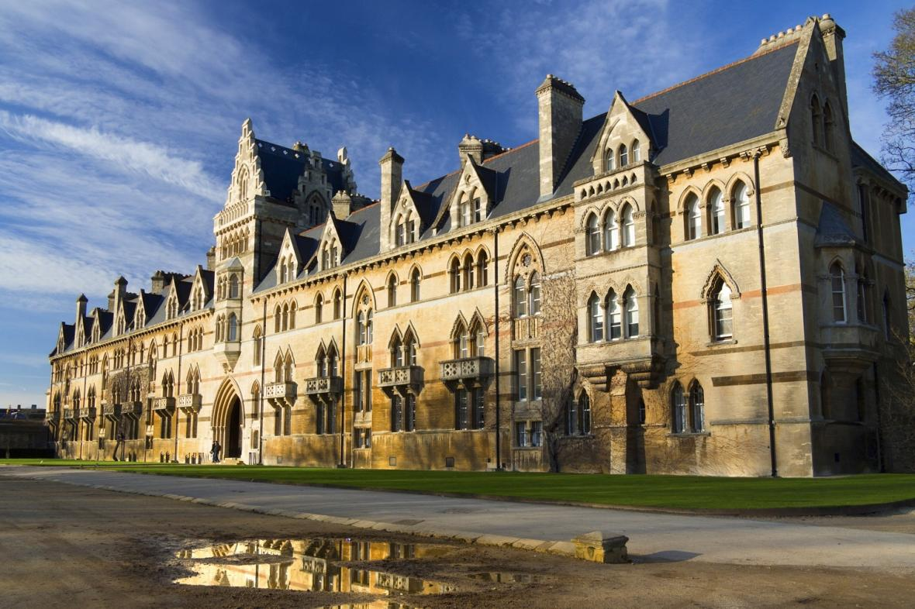
Christ Church
GETTY IMAGES
On December 12 last year the new senior censor, Geraldine Johnson, the very professor who had initially expressed her ignorance and worries about safeguarding, wrote to all staff and alumni warning them to expect further media coverage. “A motion was put to Governing Body on 4 December 2019,” she wrote, “asserting that there had been a breakdown of trust between the Governing Body and the Dean since he returned from his suspension in August. The motion was carried. Given this outcome, Governing Body will now consider what implications this has and what, if any, next steps to take.”
Percy’s next step is to take the college to an employment tribunal, likely to sit in Reading later this year or even next, where it is expected he will claim that the college failed to protect him as a whistleblower. As it awaits this second tribunal, which unlike Sir Andrew’s inquiry should be held in public, the college will continue to face ever mounting legal fees. They are already understood to stand at some £2.5 million. In this instance, Percy’s legal fees will be paid by his union, Unite. Meanwhile, attempts at mediation, offered by Christ Church, between the dean and the college are continuing but with no signs of a breakthrough.
Although he is silent now, back in 2005 I happened to interview Percy on the phone for The Times on the occasion of his elevation to Who’s Who after he had become head of a seminary training centre in Oxford. He told me he had been adopted at six weeks and gone to Merchant Taylors’ school in Hertfordshire, where he was a “rather recalcitrant, rebellious, stroppy” teenager. He graduated from the University of Bristol and entered a career in publishing. Aged 24, he was driving a rep to a bookshop near Dundee when a cyclist careered across a dual carriageway and was killed. The tragedy motivated him to trace his biological parents, but the quest resulted only in a brief meeting with the father and a note of rejection from the mother. It made him, however, reassess his life. He resigned from his job and went to study for the Anglican priesthood at Durham, the beginning of a stunning career in teaching and the Church that culminated in becoming head of Christ Church, the college and the cathedral on its grounds, in 2014 – the first dean to be democratically elected by the governing body. He’d married in 1989 and he and his wife, Emma, have two grown-up sons. He is 57.

Fifteen years ago, however, he had but one real claim on fame. He had been quoted by name by Dan Brown in The Da Vinci Code for saying that “the Bible is not a fax from Heaven”. In Oxford University, at least, he is now better known as the head of a college at permanent loggerheads with its own governing body, and for reasons few can fathom. The college has refused freedom of information requests, including ones from me, to release the Smith judgment and its many pages of appendices.

Christ Church has long had a reputation, dating at least back to Evelyn Waugh’s Brideshead Revisited, for being a haven for Hooray Henries. Its “sharking parties”, in which second and third-year males target female freshers, are of a newer folklore, for it is only 40 years since women were admitted to the college as undergraduates. It faces other travails. At present one of its dons, Dirk Obbink, is suspended pending an investigation into the disappearance of some 100 papyrus documents that were in the care of the Sackler Library in Oxford. The matter has been reported to the police. For reasons I can only guess at, since the failed attempt to remove Percy, the college has lost £2.5 million in donations and legacies.

Now Christ Church, known to itself colloquially as “the House”, faces further reputational damage for how its treatment of the dean looks to the outside world, and queries about its culture of secrecy, the competence of its governance and its commitment to safeguarding the young people in its care. In addition, “valued alumni” may want to know how it is that their alma mater has paid £2 million from college funds to two lawyers who continue to protest that their client, the college, is guilty of no wrongdoing. They may also wonder why the new senior censor, Geraldine Johnson, once so concerned about the college’s baroque inadequacies, has not apologised on the college’s behalf to its dean.
As it happens, I am a graduate of Christ Church myself, and once had the privilege of hearing Martyn Percy deliver a beautifully judged, wise and funny speech at a reunion dinner. We spoke briefly afterwards: he was candid, sympathetic and amusing. He reminded me how much I love Christ Church and what I owe it. Last month, I was kindly invited to this October’s gaudy for the 1976-1980 Christ Church student cohort to which I belong. If the invitation holds, I plan to go. The letter from the development office concluded, however, with a suggestion that I might “remember the House” in my will. I shall have to think about that.
——————————
I asked Christ Church for a response. This is what they said:
Safeguarding
There is no link between safeguarding and the pay dispute initiated by the Dean over two years ago. The Governing Body is committed to ensuring that Christ Church provides a safe environment for all, and considers safeguarding to be of the highest importance. We are confident that all safeguarding policies met statutory requirements throughout the period in question.
Smith tribunal and confidence vote
The disciplinary case heard by Sir Andrew Smith was carried out as prescribed in Christ Church’s statutes, which were adopted based upon the advice of the Charity Commission in 2011. The decision to proceed with the complaint against the Dean was supported by a vote of 43 to 1 in the Governing Body and unanimously by the Cathedral Chapter. It is entirely normal for internal disciplinary hearings to be held in private and this was done with the full agreement of the Dean.
In December 2019, a vote of no confidence was put to the Governing Body by 16 of its members. The result, which is in the public domain, was 38 voted that they had no confidence in the Dean, with 2 against the motion.
Employment tribunal
We can now confirm that we are in receipt of two Employment Tribunal claims from the Dean of Christ Church. We are all too conscious that what began as a request for a sizeable salary increase by the Dean has led, over the last two years, to significantly-heightened tensions between him and an overwhelming majority of Governing Body. Personal relationships have undoubtedly suffered, and we all regret this deeply. We take our responsibilities towards all members of our community very seriously, and believe that we have acted in the best interests of Christ Church, including its students and staff.

We recognise the anguish that the Dean has previously expressed regarding the level of his remuneration, and his concerns are reflected in the latest papers lodged with the Employment Tribunal. The Governing Body maintains that the Dean’s total remuneration package, which amounts to a significant six-figure sum, is fair and generous, and follows guidance provided by the Charity Commission. As well as a base salary, which has increased twice since 2017, he and his family are entitled to the rent-free use of the 12-bedroom Deanery.
Legal fees
The Governing Body remains committed to achieving a satisfactory resolution. Christ Church would need explicit permission from the Charity Commission to reimburse the Dean’s legal costs. However, the Governing Body is funding an ongoing mediation process in full, in order to find a way forward and to limit further expense.

